H.T No
Regulations:
A15

Sreenidhi Institute of Science and Technology
(An Autonomous Institution)
Code No: 5A304 Date: 03-Nov-2020 (FN)

B.Tech II-Year I-Semester External Examination, Oct/Nov - 2020 (Supplementary)
Circuits and Networks-II (EEE)

Time: 2 Hours Max.Marks:75

Note: a) No additional answer sheets will be provided.
b) All sub-parts of a question must be answered at one place only, otherwise it will not be valued.
c) Missing data can be assumed suitably.

ANSWER ANY 5 OUT OF 8 QUESTIONS. EACH QUESTION CARRIES 15 MARKS.
1. | a) | Three equal impedances each of (8+j10)Ω, are connected in star. This is further connected to a 440V, 50Hz, 3-ϕ phase supply. Calculate  (i) phase voltage (ii) phase current (iii) active power and (iv) reactive power. | [8M]
 | b) | A symmetrical 440V, 3-ϕ system supplied a star-connected load with the Z_{R}=10Ω, ZY=j5Ω, ZB= -j5Ω as shown in below fig. Calculate line currents and voltage across each phase impedance by Millman’s theorem. The phase sequence is RYB.  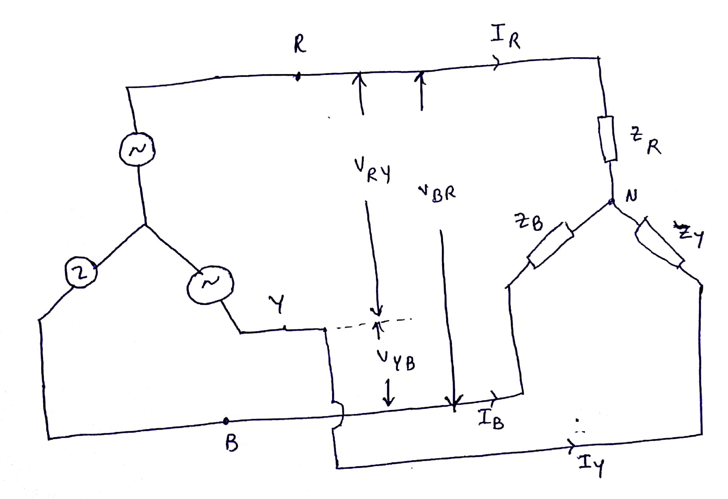 | [7M]
2. | a) | In the network shown in below figure the switch is closed. Assuming all the initial condition as zero, find I, di/dt and d²i/dt² at t=0⁺.  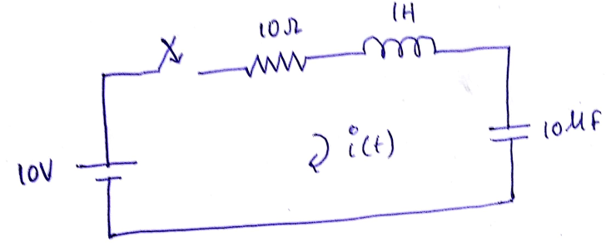 | [8M]
 | b) | In the network shown in below figure, the switch is closed at t=0. Find the currents i₁(t) and i₂(t) when initial current through the inductor is zero and initial voltage on the capacitor is 4v using Laplace transform.  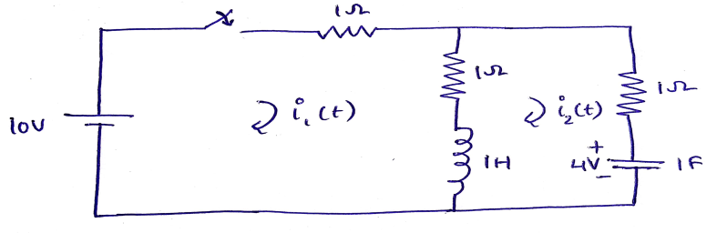 | [7M]
3. | a) | Determine the driving point impedance of the network shown in below figure.  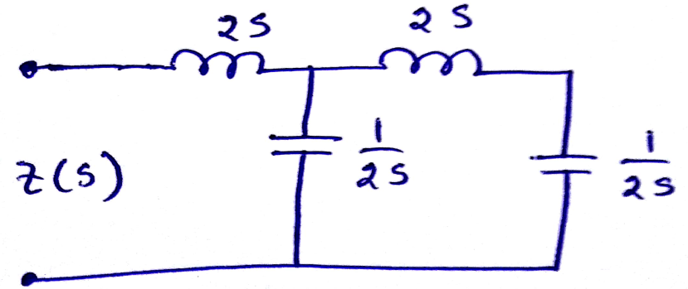 | [8M]
 | b) | For the network shown in below figure, plot poles and zeros of function of I₂/I_{1.}  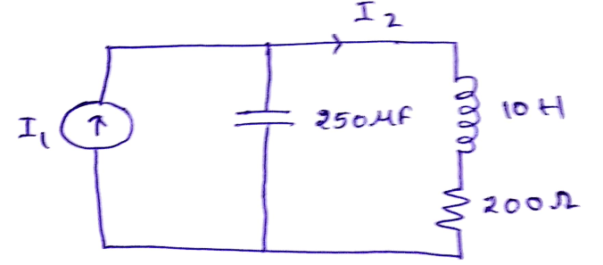 | [7M]
4. | a) | Find the open circuit impedance parameters for the network shown in below figure. Determine whether the network is symmetrical and reciprocal.  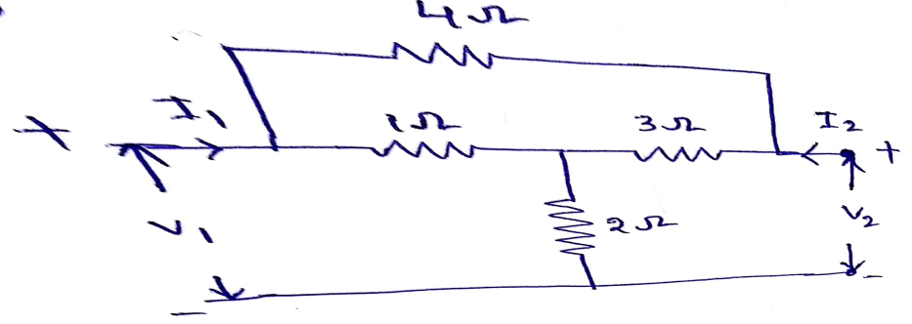 | [8M]
 | b) | Find Y parameters for the network shown in below figure.  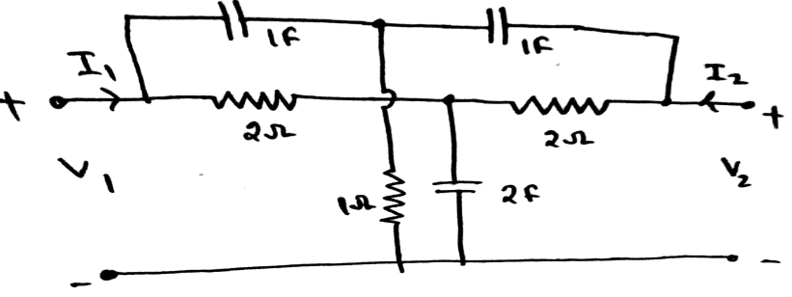 | [7M]
5. | a) | A Π-section filter network consists of a series arm inductor of 20mH and two shunt arm capacitors of 0.16µF each. Calculate the cut-off frequency, and attenuation and phase shift at 15kHz. What is the value of the nominal impedance in the pass band. | [8M]
 | b) | In a constant-K band pass filter, the ratio of capacitances in the shunt and series arms is 100:1. The resonant frequency of both arms is 1000Hz. Find the bandwidth. | [7M]
6. | a) | Find the exponential Fourier series of the waveform shown in below figure. Draw the magnitude spectrum.  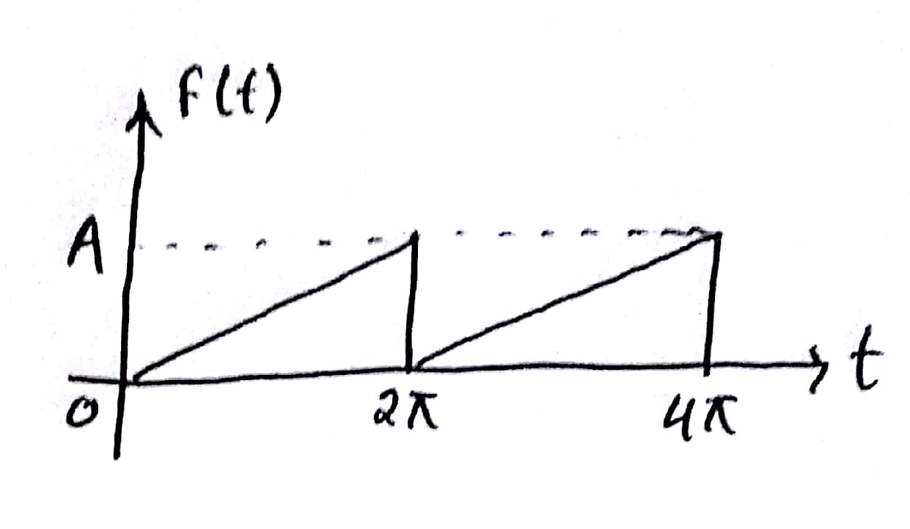 | [8M]
 | b) | Find the Fourier transform of the function shown in below figure.  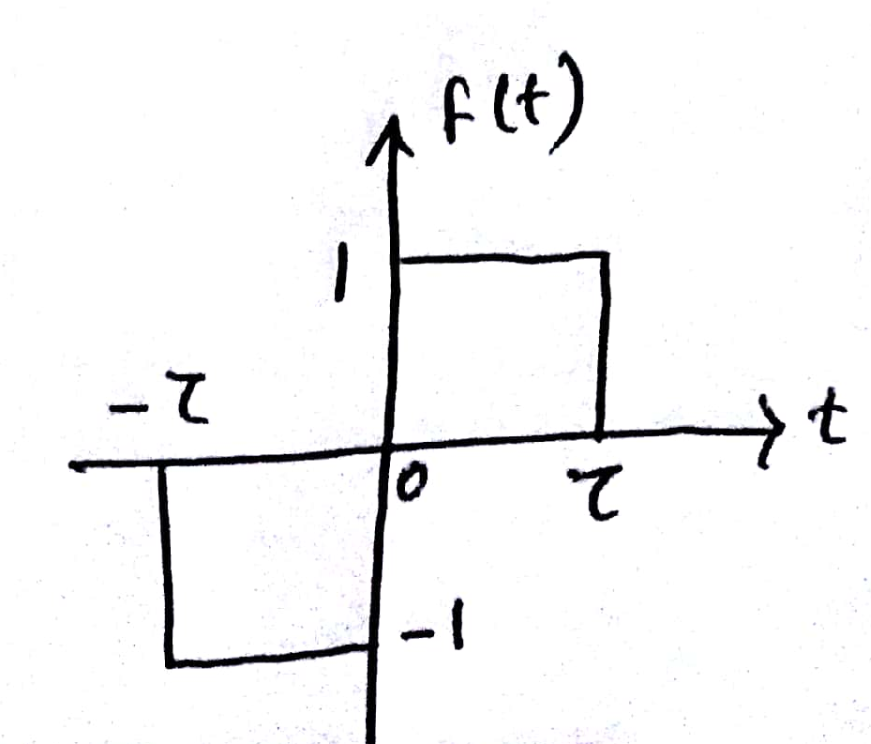 | [7M]
7. | a) | Obtain an expression for phase angle of star connected load by using two watt meter method and by using necessary phasor diagrams. | [8M]
 | b) | Derive exponential response of series RC circuit. | [7M]
8. | a) | Derive the expressions and draw the equivalent circuit for representing a two port network by means of Hybrid parameters. | [8M]
 | b) | Write about analysis of Band stop filter. | [7M]

-- 00 -- 00 –

